
AI CAREER FOR WOMEN
Science

Demand Forecasting for Retail Store
A Project Report
submitted in partial fulfillment of the requirements
of
AICW project.

by

K. Lohitha Tejasvi, lohitha290705@gmail.com
D. Vaishnavi, debbatavaishnavi8@gmail.com
B. Sindhu, bandasindhu2846@gmail.com
Lavanya Patil, lavanyapatil537@gmail.com

Under the Guidance of
Sai Baba Basha

ACKNOWLEDGEMENT

we would like to thank my supervisor, sai baba basha sir for being a great mentor and the best adviser. His advice, encouragement and the critics are a source of innovative ideas, inspiration and causes behind the successful completion of this project. The confidence shown in me by him was the biggest source of inspiration for me. It has been a privilege working with him for the last one year. He always helped me during my project and many other aspects related to the program. His talks and lessons not only help in project work and other activities of the program but also make me a good and responsible professional.

ABSTRACT of the Project

Accurate demand forecasting is essential for efficient business planning and inventory management. This project presents a demand forecasting approach using a Long Short-Term Memory (LSTM) neural network to predict future demand based on historical data. The LSTM model effectively captures temporal patterns and long-term dependencies in time-series data, resulting in improved forecasting accuracy. The proposed model supports data-driven decision-making and enhances operational efficiency.

TABLE OF CONTENTS
- Abstract
- Chapter-1:
- Introduction
- Problem Statement
- Motivation
- Objective

: Literary survey

: Methodolgy

CHAPTER 1
Introduction

Demand forecasting is an essential process for predicting future product demand to support effective inventory management and business planning. Traditional forecasting methods often fail to capture complex patterns in time-series data. Long Short-Term Memory (LSTM), a type of Recurrent Neural Network (RNN), is well suited for demand forecasting as it can learn long-term dependencies and handle non-linear patterns in historical data. In this project, an LSTM-based model is used to analyze past demand data and predict future demand, helping organizations make accurate and data-driven decisions.

Problem Statement: Every retailer must stay on top of planning activity to stand the demand of goods based on needs. A highly accurate demand forecast is the only way retailers can predict which goods are needed for each store location. This will also ensure high availability for customers while maintaining minimal stock risk and support capacity management, store staff labour force planning, etc.
The project will use ARIMA, SARIMA, RNN, LSTM & PROPHET, which is very suitable for handling time-series data and widely used for forecasting purposes.
Motivation: Demand forecasting has roots stretching back to ancient merchants who intuitively gauged needs based on seasonal patterns and local trends, but it truly formalized during the Industrial Revolution in the 19th century. As mass production ramped up, businesses shifted from gut feelings to basic quantitative tools like moving averages, which used historical sales averages to project future demand and manage growing inventories more systematically.
Objective: To improve forecasting accuracy compared to traditional methods
- To analyze historical demand patterns in time-series data
- To forecast future demand using an advance statistical models
- To support effective inventory and business planning decisions

CHAPTER 2
Literature Survey
By the early 20th century, techniques such as exponential smoothing and ARIMA models emerged, capturing trends, seasonality, and irregularities in data for more reliable predictions in manufacturing and retail. The mid-20th century brought computers, enabling complex simulations and vast data processing that dramatically boosted accuracy and efficiency.
ARIMA: ARIMA (AutoRegressive Integrated Moving Average) is a method used to analyze and forecast time series data by combining three components—autoregression, differencing, and moving averages—to capture patterns and predict future values.
SARIMA: SARIMA (Seasonal AutoRegressive Integrated Moving Average) is an extension of ARIMA used for time series data with seasonal patterns. It includes additional seasonal terms to capture repeating trends over fixed intervals, making it suitable for forecasting data with periodic fluctuations.
RNN: RNN (Recurrent Neural Network) is a type of neural network designed for sequential data, where information from previous steps is used to influence current predictions. It has loops that allow it to retain memory, making it useful for tasks like time series forecasting, speech recognition, and language processing.
LSTM: LSTM (Long Short-Term Memory) is a type of Recurrent Neural Network (RNN) designed to remember long-term dependencies in sequential data. It uses special gates (input, forget, and output) to control the flow of information, helping it avoid problems like vanishing gradients and making it effective for tasks like time series prediction and language modeling.
PROPHET: Prophet is a time series forecasting model developed by Meta Platforms that is designed to handle seasonality, trends, and holidays easily. It is simple to use and works well even with missing data and irregular patterns.

CHAPTER 3
Methodology
The demand forecasting project followed a structured methodology to ensure accurate and reliable predictions:
- Data Collection & Preprocessing
  - Historical demand data was gathered from relevant sources.
  - Missing values were handled, outliers were treated, and the data was normalized where necessary.
  - Stationarity checks (ADF test) and transformations (differencing, log scaling) were applied to prepare the data for time series models.
- Exploratory Data Analysis (EDA)
  - Trend, seasonality, and cyclic patterns were identified using visualization techniques.
  - Correlation and autocorrelation plots (ACF, PACF) guided model selection.
- Model Development
  - ARIMA: Applied for stationary series to capture autoregressive and moving average components.
  - SARIMA: Extended ARIMA to incorporate seasonality.
  - RNN & LSTM: Implemented deep learning models to capture sequential dependencies and complex non-linear patterns.
  - Prophet: Used for interpretable forecasting with built-in handling of seasonality, holidays, and trend shifts.
- Model Training & Validation
  - Data was split into training and testing sets.
  - Hyperparameters were tuned using grid search and cross-validation.
  - Performance was evaluated using metrics such as Mean Absolute Error (MAE), Root Mean Squared Error (RMSE), and Mean Absolute Percentage Error (MAPE).
- Comparison & Analysis
  - Forecast accuracy, interpretability, and computational efficiency were compared across models.
  - Strengths and limitations of each approach were documented to guide practical application.

This methodology ensures a systematic approach — from data preparation to model evaluation — enabling robust demand forecasting and providing insights into which model best suits different business scenarios.

CHAPTER 4
Implementation and Result
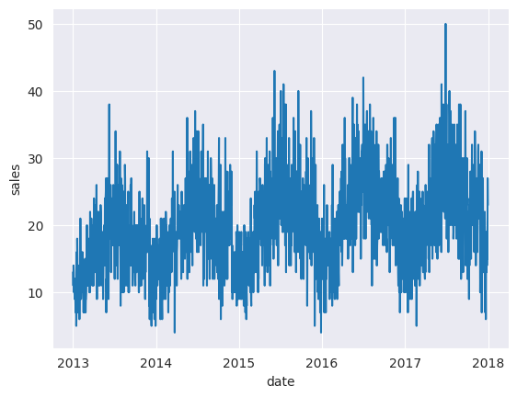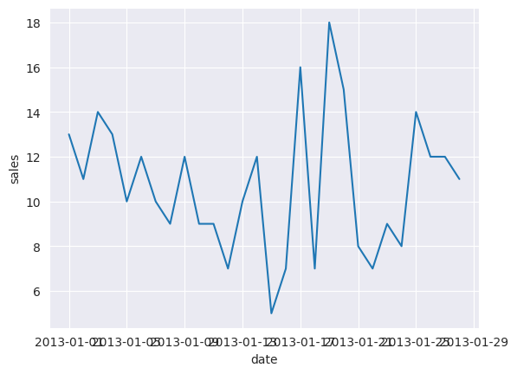

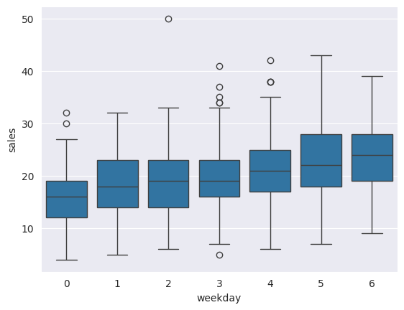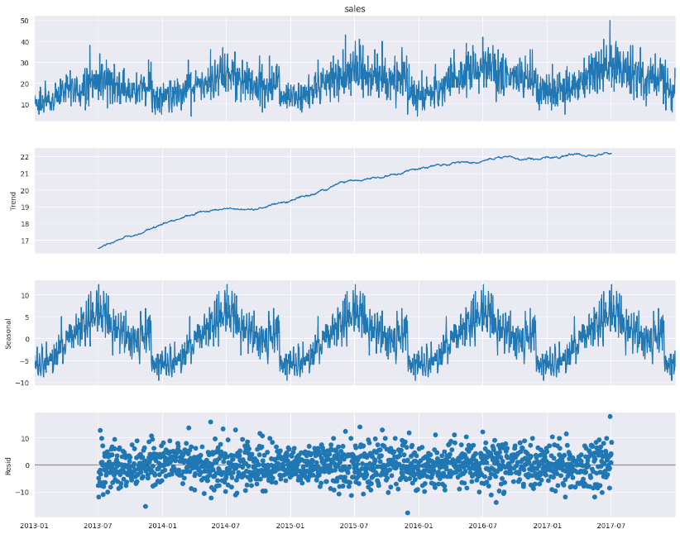
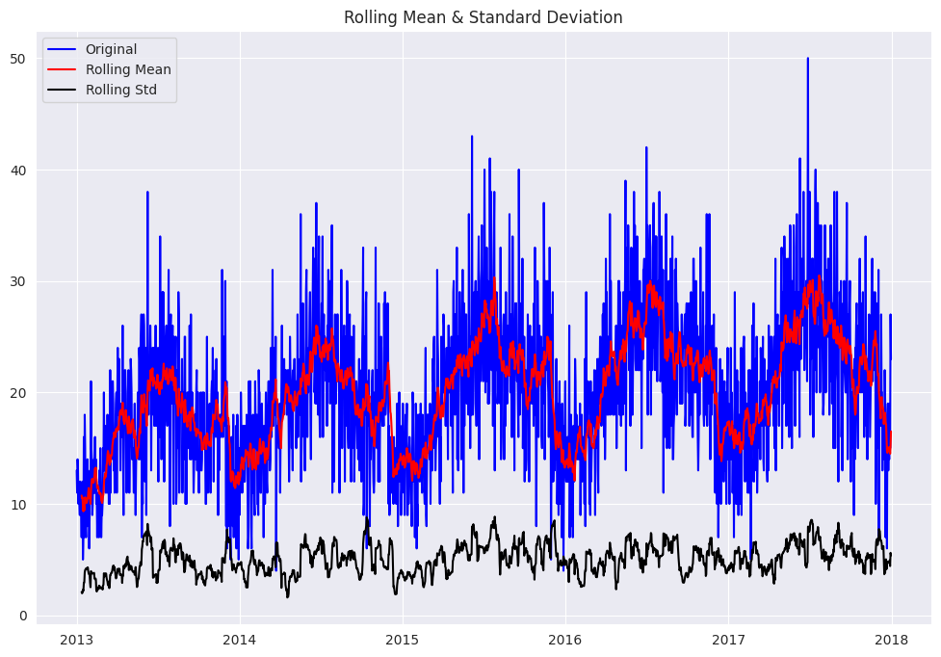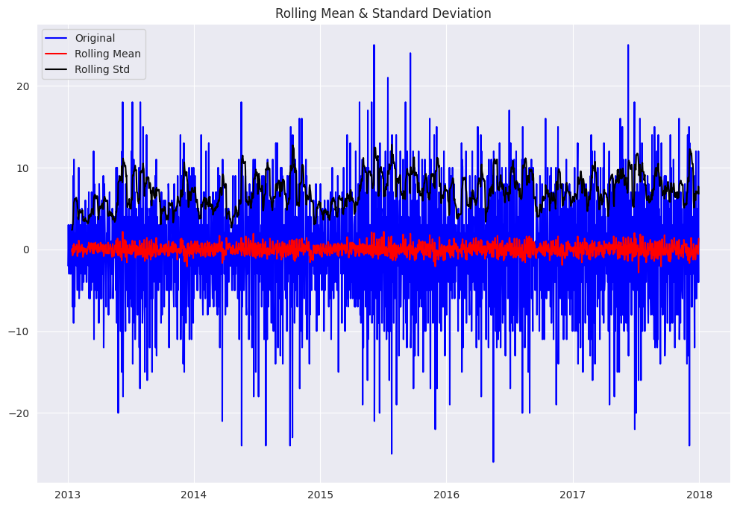

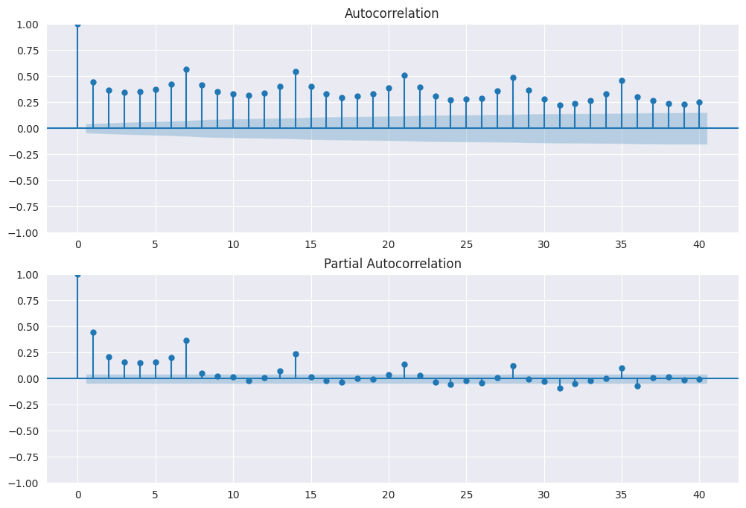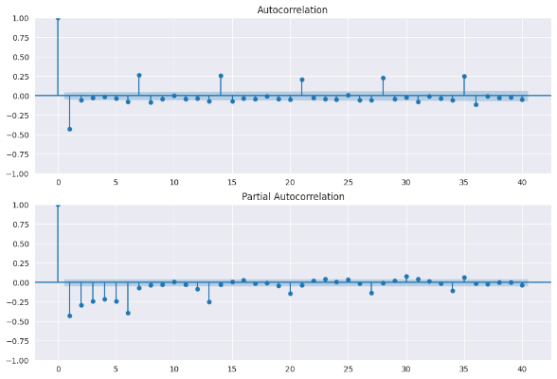
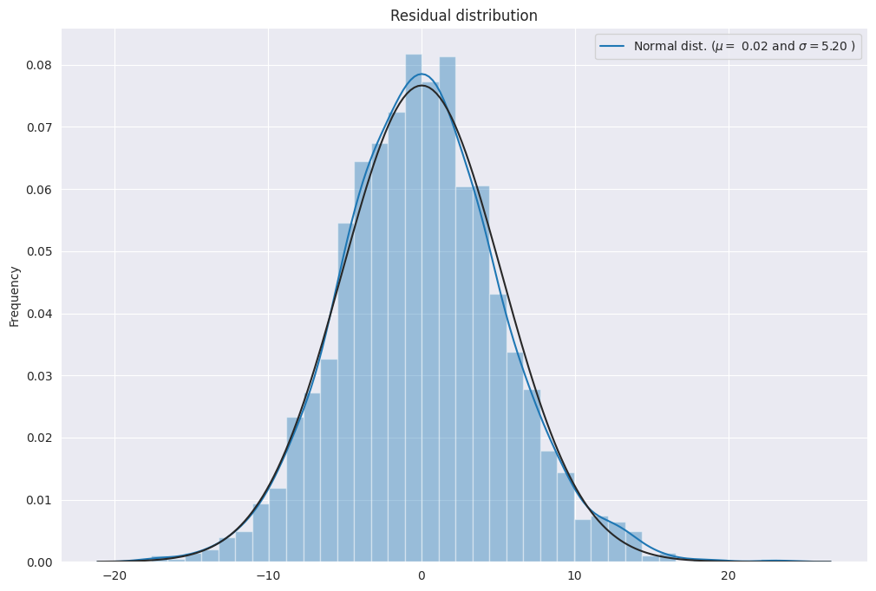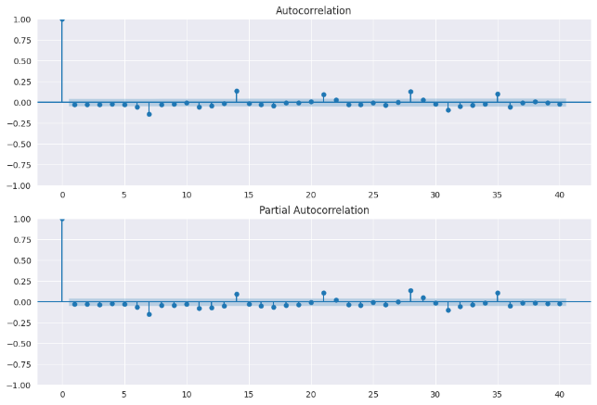
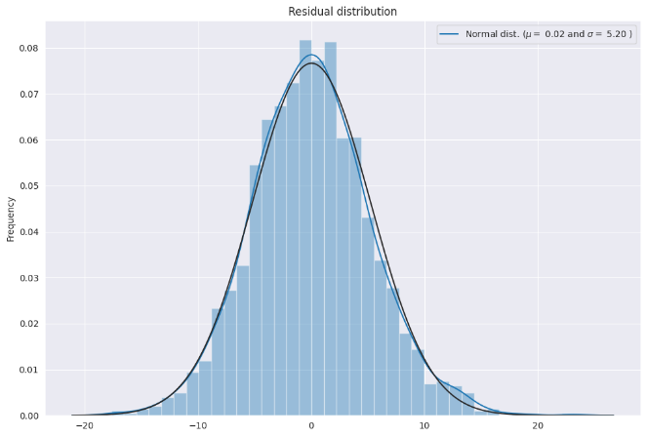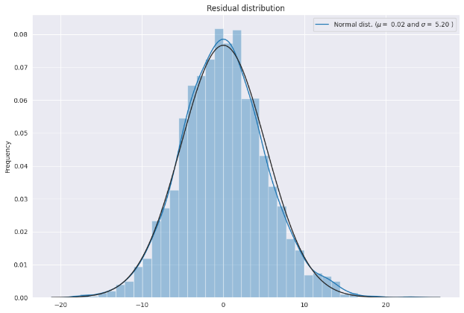
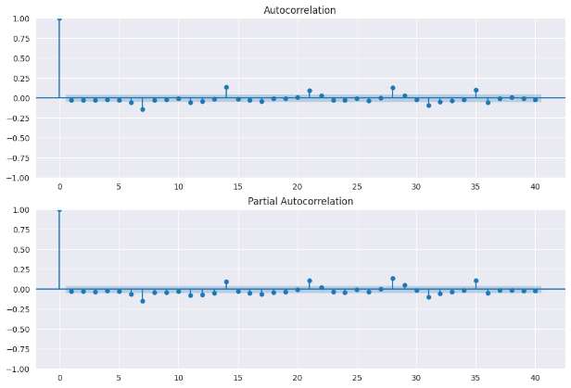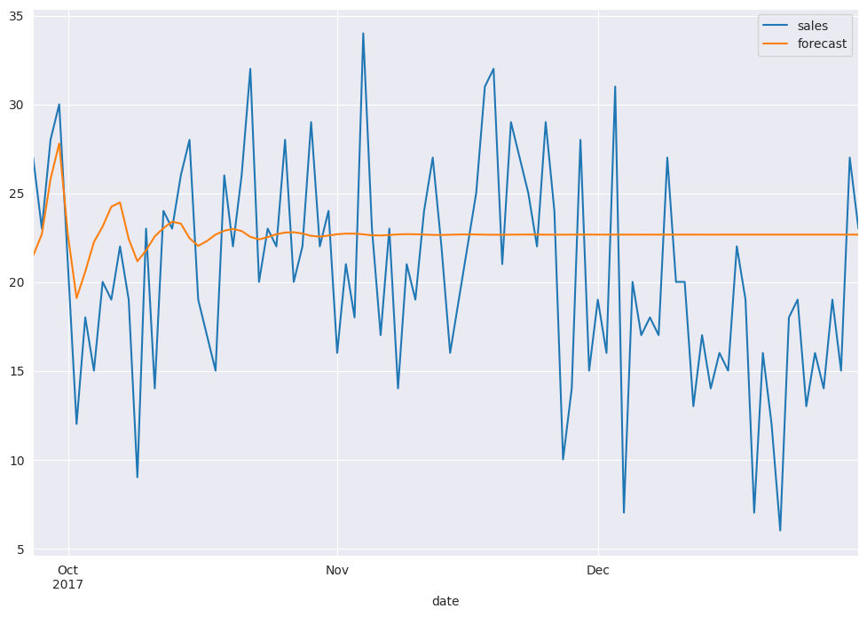
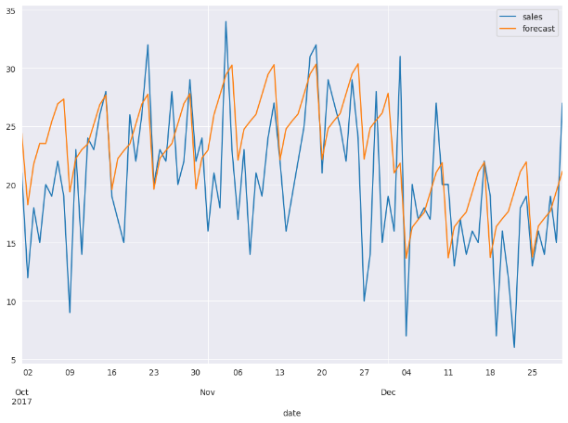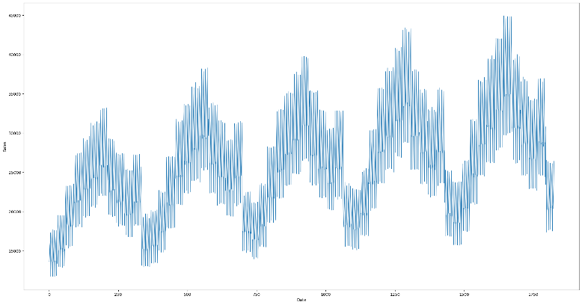
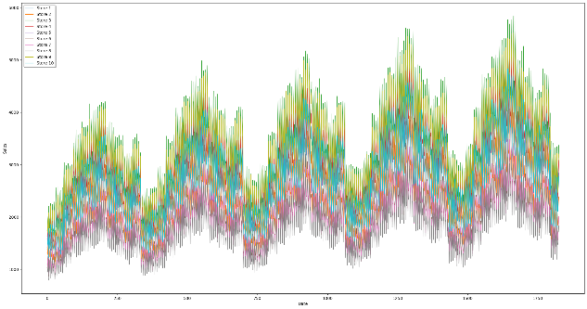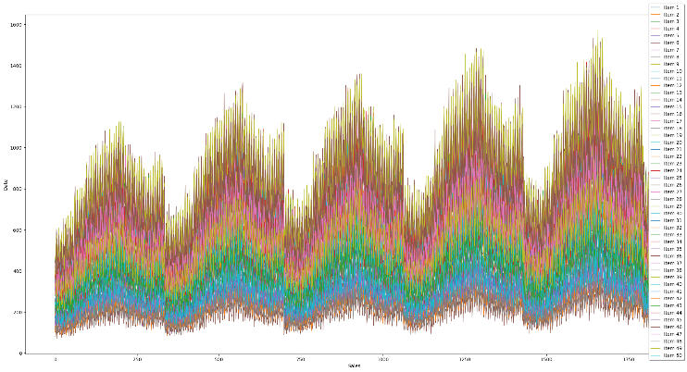
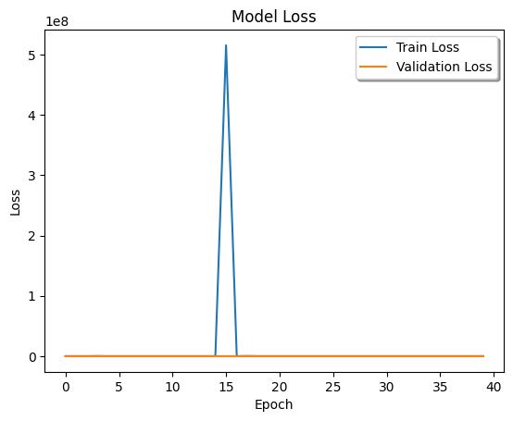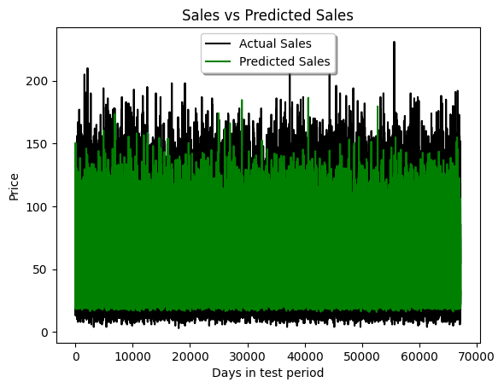
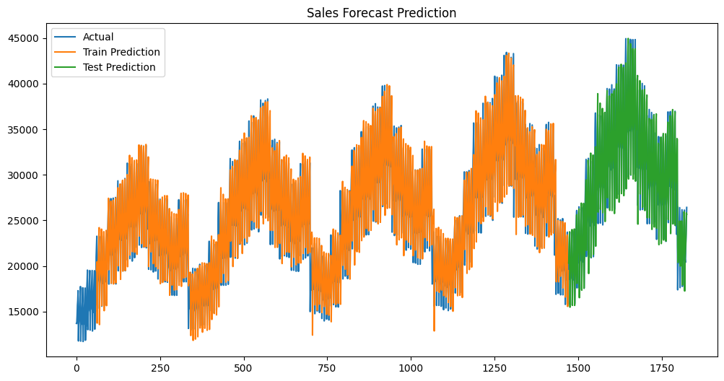
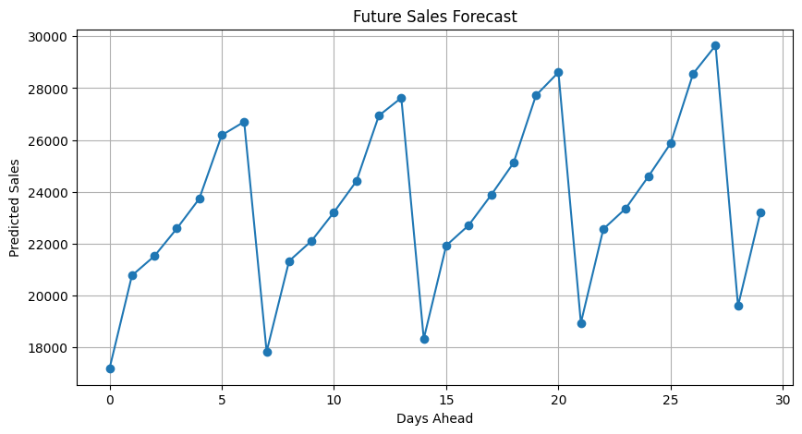
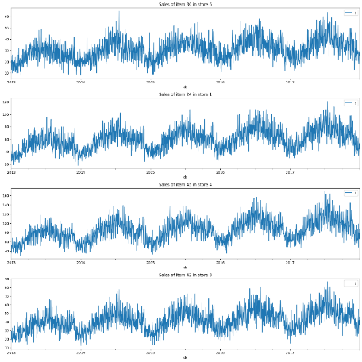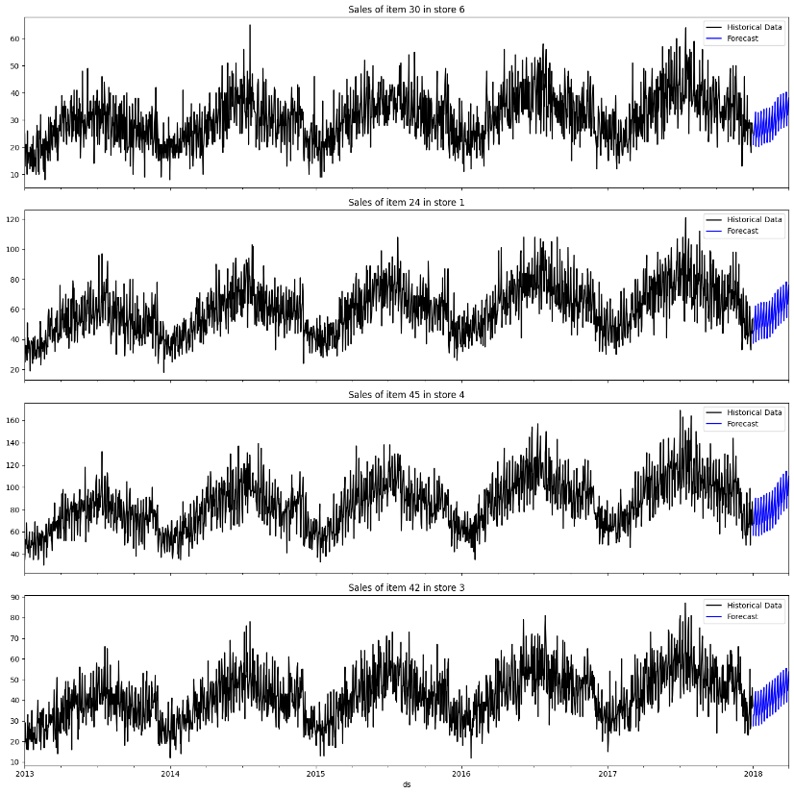

CHAPTER 5
Discussion and Conclusion
In this project, we explored multiple forecasting models — ARIMA, SARIMA, RNN, LSTM, and Prophet — to predict demand patterns. Each model demonstrated distinct strengths and limitations:
- ARIMA: Effective for short-term forecasts on stationary data, but limited in handling seasonality and complex patterns.
- SARIMA: Extends ARIMA by incorporating seasonality, making it suitable for datasets with cyclical demand trends.
- RNN: Captures sequential dependencies but struggles with long sequences due to vanishing gradients.
- LSTM: Overcomes RNN’s limitations, excelling at modeling long-term dependencies and complex, non-linear demand patterns. Requires larger datasets and computational resources.
- Prophet: User-friendly and interpretable, designed for business applications. Handles seasonality, holidays, and trend shifts well, though less powerful than LSTM for highly complex data.

- Simple demand patterns → ARIMA is sufficient.
- Seasonal demand → SARIMA or Prophet provide reliable forecasts.
- Complex, non-linear demand → LSTM offers the most robust performance.
- Business-friendly forecasting → Prophet balances ease of use with accuracy.

  - Git Hub Link of the Project: Share the GitHub link
  - Video Recording of Project Demonstration: Record the demonstration of the Project and share the relevant link.

REFERENCES

Datasets: https://www.kaggle.com/code/samyabose/demand-forecasting-using-lstm
Codes: https://www.kaggle.com/c/demand-forecasting-kernels only/data?select=train.csv

Appendices (if applicable)
Include any additional information such as code snippets, data tables, extended results, or other supplementary materials.

